How to set up a JustGiving page for your Danceathon Event

- Copy this link into the internet. https://www.justgiving.com/campaign/danceathoncharitychallenge
This will take you to our Danceathon Campaign page (as seen below).
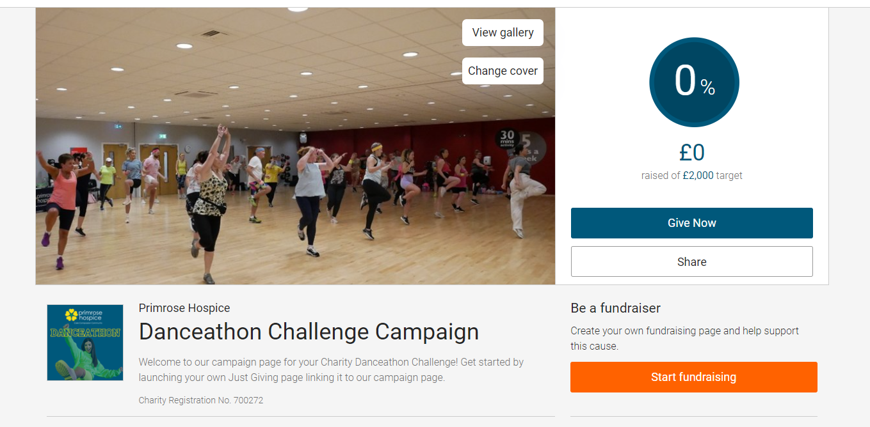

If you don’t have an account already, you will be prompted to make one. Otherwise, you can log in here.
- Then click on “Start Fundraising”
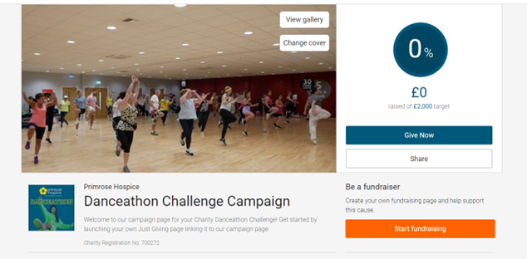

- Start to fill in all the details – select “I’m doing my own activity” and include details about your event.
- Personalise your page - It’s always a good idea to include your reasons for supporting and taking part in the event, as this will encourage your supporters to donate!
- Share, share, share! Get the word out to friends and family to raise as much as possible!

